**White Belt (Jukyu) Practice Schedule**

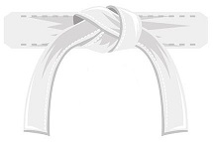

Week 1 – Skill focus – Developing proper front punch

1. Review White Belt Lesson 1 Proper Front Punch
2. Practice 3 sets of 10 front punches each day. Focus on proper technique!

Week 2 – Skill focus – Developing proper front kick

1. Review Yellow Belt Lesson 2: Proper Front Kick
2. Practice 3 sets of 10 front kicks and 3 sets of 10 front punches.

Then when you’re ready, proceed to your White Belt Test! This will help you get accustomed to the process of testing.

You should have already received your uniform and white belt by the time you take the test. The reason for doing the test is primarily to help you understand the process of testing.

Good Luck,

Karate Academy Team!